https://www.tenforums.com/tutorials/3373-setup-run-windows-10-usb-flash-drive.html:
How to Setup and Run Windows 10 on USB Flash Drive (www.tenforums.com)

Information
This tutorial will show you how to manually setup Windows 10 To Go from any Windows 7 or Windows 8/8.1 system and run Windows 10 from a USB flash drive. The same procedure can be applied for an installation on an external SSD.
You should expect the whole process to take about 3 hours elapsed time if you do not have the WAIK on your system and about 1 hour if the WAIK is installed on your system.
It is very important to choose a fast USB stick of at least 16GB size. It is preferable to use a USB3 attachment, but USB2 will also work at a slower pace.
In addition, you need a program to create a virtual CD and the Windows10 .iso. The rest is done in Command Prompt.

Note
Those of you who have an Enterprise edition of Windows10, you can also explore this option which is built into the Enterprise edition.

Note
This was additional information provided by Yasak Hayat:
First of all no need to download whole AIK kit for just imagex.exe
Imegex.exe can get from MS web site. Here for x86 and here for x64
Second thing is; Windows 8 and 10 have already create virtual driver capability: ISO and IMG File - Mount or Unmount in Windows 10

Contents
Step 1 – Check the speed of your USB stick 2
Step 2 – Download the WAIK and extract the imagex file 3
Step 3 – Mount the Windows 10 .iso in a virtual BD ROM 4
Step 4 – Prepare your USB stick 5
Step 5 – Install Windows 10 on the stick 6
Step 6 – Run Windows 10 from your USB stick 7
Have fun and enjoy 7
Related Tutorials 7

Step 1 – Check the speed of your USB stick
To measure the speed of your stick I recommend HD Tune. It provides data regarding the data transfer rate and the access time. The most important is the access time. Ideally it should be under 1ms. I use this stick. Note the data transfer time (red) comparable to a HDD and the access time (green) of 0.3ms close to a SSD which is appr. 50 times faster than the access time on a HDD.
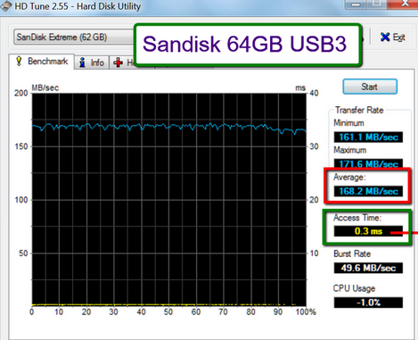Step 2 – Download the WAIK and extract the imagex file
If you do not have the WAIK (Windows Automated Installation Kit) on your system, then you have to download from this Microsoft site. This will be a bit lengthy because the WAIK is 1.7GB - figure an up to 2-hour download.
Then you have to copy the imagex.exe. You find that in C:\Program Files\Windows AIK\Tools. There is a 32bit version and a 64bit version.
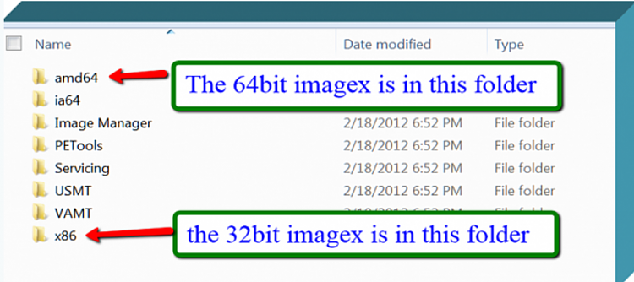
You choose 32bit when you install a 32bit version of Windows 10 on your stick - 64bit when you install the 64bit version. Copy the imagex.exe ​that corresponds to your Windows10 .iso to the desktop. You can copy it to any other folder, but then you have to change the path in the installation command that we will run later in Command Prompt.

Step 3 – Mount the Windows 10 .iso in a virtual BD ROM
We first have to create a virtual BD ROM with the Virtual Clone Drive Program. Download, install and run this program. It is very simple. When you start the program, you get the window below. Just click OK and you are done. You then go to Computer and you find your BD ROM.
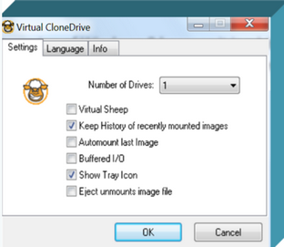
To mount the .iso into the BD ROM, follow the instructions in the next picture. Make sure you remember the drive letter of the BD ROM (in my case 'H:') because you will need that later.
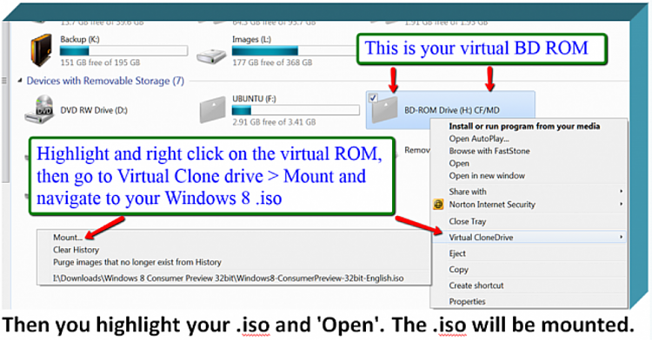

Step 4 – Prepare your USB stick
We now have to define a primary active partition on the USB stick. For that we open an elevated Command Prompt (run as administrator). Type or paste each of the following commands (one by one) and hit Enter after each command.
Diskpart
List disk
Select disk n (where n is the number that was given for your stick in List disk)
Clean
Create partition primary
Format fs=ntfs quick
Assign
Active
Exit
Your stick is now ready for the installation of Windows10.

Step 5 – Install Windows 10 on the stick
This is very easy now with a command in Command Prompt. It may take a little while to transfer the whole system, so be patient. The Command is:
"C:\Users\Your Name\Desktop\imagex.exe" /apply H:\sources\install.wim 1 F:\
Your Name is the name of your system. H: is the letter of my BD ROM (step 3). If your BD ROM has another letter, you have to change that accordingly. F: is the drive letter of my stick (step 4). Here you also have to replace it if your stick is on another letter.
As last step you have to run a command to install the boot files.
bcdboot F:\windows /s F:
Here again F: is the letter for my stick which you may have to adjust.

Step 6 – Run Windows 10 from your USB stick
Note
The first thing you will have to do is the Windows 10 normal installation. During this process, Microsoft requires a check number which they will send you to your email. Therefore make sure you have access to your emal from another device.
When you are done with the installation, you can run Windows 10 from your stick. For that you have to change the boot sequence in the BIOS pointing at the USB stick as first boot device.
I run the stick version on my laptop, I made the USB stick#1 in the permanent boot sequence. That way it loads Windows 10 from the stick when the stick is plugged in and Windows 7 from the system SSD when there is no Windows 10 stick.

Have fun and enjoy

Related Tutorials

  - How to Install and Run Windows on a USB Drive using WinToUSB
  - How to Create a Windows To Go Workspace USB in Windows 10

